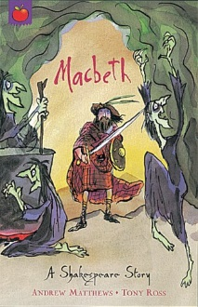
English – Our first English writing unit will be ‘Poems with Imagery’. We will be looking at how authors create vivid images in our minds using language effects. Children will be able to identify examples of figurative language within poems including metaphor, simile and personification.
Grammar & Punctuation – We will be focusing on modal verbs, formal language, emotive language, active and passive sentences, inverted commas, colons, semicolons and dashes.
Guided Reading – We will be looking at the how different texts have been structured and why, discussing the impact on the reader. Children will be able to describe the effect figurative language has on the reader. We will explore the meanings of words in context and discuss their impact on the reader.

Maths – We will be exploring: Place value, sequences and coordinates, 2D shape, coordinates, translation and reflection, Measurement – temperature, negative numbers, Calculating with fractions (multiply and divide), Mental and written division, Mental and written multiplication

Science – Our science unit this half term will be Animals / Health and the Circulatory System. We will be learning to identify and name the main parts of the human circulatory system, and describe the functions of the heart, blood vessels and blood. We will recognise the ways in which nutrients and water are transported within animals, including humans. The unit will also help us recognise the impact of diet, exercise, drugs and lifestyle on the way our bodies function.
Design and Technology – We will be linking our D&T to our science unit and designing a healthy menu. We will market this as a product to sell. A number of children in the class have shown an interest in vegan diets, it will be a good idea to design, make and evaluate a vegan meal.

P.E – Our PE unit this half term is going to be Gymnastics. We will perform a wide variety of gymnastic skills and techniques to eventually put into a performance by the end of the block of sessions.
* I will try and plan these activities as best I can to work for remote learning. There may be some changes and different activities added to make it easier to perform at home.
R.E. – The focus of our RE lessons this half term will be to explore what it means for a person to have faith and how having faith affects people’s lives, values and decisions.

ICT – We are going to be combining activities from Technola and using a variety of skills to support our D&T project such as: research, developing questionnaires and producing data.

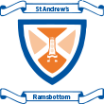
Year 5/6 Spring 1 Topic Plan
Heroes and Villains

