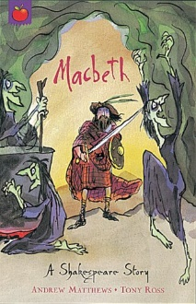
English – Our English writing will be based on MacBeth (Andrew Matthews version and Shakespeare). We will be using this text as part of our Classic Fiction unit of writing. We will also be writing poetry and comparing poems to song lyrics. Our final genre of writing will be ‘persuasion’, and children will be writing a formal review of a performance.
Grammar & Punctuation – We will be focusing on modal verbs, formal language, emotive language, active and passive sentences, inverted commas, colons, semicolons and dashes.
Guided Reading – We will be using the text to discuss our understanding of the text, draw inferences and justify inferences with evidence, identify key details that support the main ideas, to draw inferences by inferring characters’ feelings and to discuss and evaluate the author’s choices.

Maths – We will be exploring 1. Fractions / percentages (comparing / ordering, equivalent fractions, fractions of amounts, mixed numbers and improper fractions, fractions to decimals). 2. Geometry / angles and statistics (choosing appropriate strategy, solving multi-step problems, estimation, adding / subtracting decimals). 3. Measurement (length/ weight/ area and volume)

Science – Our science unit this half term will be Light and Astronomy. We will be learning about how light travels, how we see, how light gets into our eyes, how we can use mirrors to see behind us, how shadows created by the sun change during the day, how we can represent light travelling in drawings, and how light behaves.

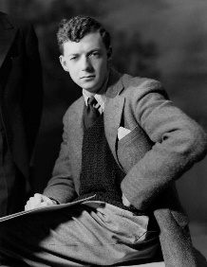
Music – With a focus on composer Benjamin Britten (1913-1976), pupils will travel through time to discover how musical influences have changed over the years whilst still retaining the same elements that put ‘pop’ into popular music. This will then lead pupils to compare music from the ‘X Factor’ phenomenon alongside their original versions.

This unit provides an opportunity to research, listen to and perform songs from an eclectic range of styles and genres.

P.E – Our PE unit this half term is going to be on basketball. Children will focus on the key skills of passing, catching, dribbling and shooting.

R.E. – The focus of our RE lessons this half term will be Christianity and the Nativity.

ICT – We are going to be looking at coding with Technola in our ICT lessons this half term.

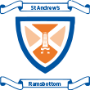
Year 5/6 Autumn 1 Topic Plan
Britten’s Got Talent

