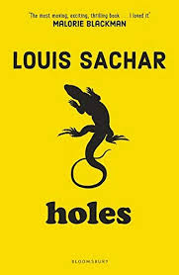
English – Our English writing will be based on the book ‘Holes’ by Louis Sachar. We will be using this text to write non-chronological reports, informal letters and a range of descriptive writing. We will also attempt two write our own final chapter using the same style and structure used by the author.
Grammar & Punctuation – We will be revising word classes during the first week of the half term. Then we will focus on phrases and clauses, expanded noun phrases and active and passive verbs.
Guided Reading – We will be using the text to discuss our understanding of the text, draw inferences and justify inferences with evidence, identify key details that support the main ideas, to draw inferences by inferring characters’ feelings and to discuss and evaluate how the author has used figurative language.

Maths – We will be exploring 1. Place Value (numbers to 1 million and 10 million, ordering numbers, negative numbers, counting to the power of 10, rounding numbers). 2. Mental / written addition and subtraction (choosing appropriate strategy, solving multi-step problems, estimation, adding / subtracting decimals). 3. Geometry / measures and shape (angles, perimeter, measurements and calculating measurements, draw shapes and nets)

Science - Building on what they have learnt about fossils in the topic on rocks in Year Three, pupils will find out more about how living things on earth have changed over time. They will be introduced to the idea that characteristics are passed from parents to their offspring, for instance by considering different breeds of dogs, and what happens when, for example, labradors are crossed with poodles. They should also appreciate that variation in offspring over time can make animals more or less able to survive in particular environments, for example by exploring how giraffes’ necks got longer, or the development of insulating fur on the arctic fox. Pupils will find out about the work of palaeontologists such as Mary Anning and about how Charles Darwin and Alfred Wallace developed their ideas on evolution.
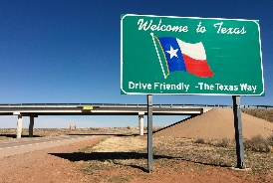
Geography – In Geography, we have decided to focus on Texas to learn about the physical geography of a region. As a class, we decided this would be a good place to study because it is the setting of our book Holes! We will look at climate zones, biomes and vegetation belts. We will also explore the human geography, including: types of settlement and land use, economic activity and trade, and also the distribution of natural resources.
We will also be looking at locational knowledge, mapping and using ICT to understand satellite imagery and use online mapping.
P.E – Our PE unit this half term is going to be on Health and Fitness. This will link well with our Science topic and will give us the opportunity for some cross-curricular learning. We will be creating some of our own fitness circuits and understanding how exercise impacts the body.
R.E. – The focus of our RE lessons this half term will be Jesus and Christianity.
ICT – We are going to be looking at coding with Technola in our ICT lessons this half term.

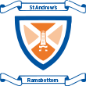
Year 5/6 Autumn 1 Topic Plan Survival!

