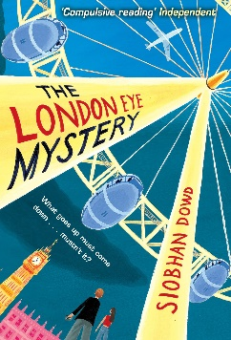
English – Our first English writing unit will be the ‘Detective / Crime Fiction’ genre. We will be using the book ‘The London Eye Mystery’ by Siobhan Dowd as our main text throughout this unit. The focus of this unit will be to understand the underlying themes, causes and consequences within whole texts and recognise authors’ techniques to influence and manipulate the reader. We will also analyse the conventions of different types of writing, e.g. detective fiction: red herring, motive, alibi, alias, the reveal.
Grammar & Punctuation – We will be focusing on active and passive sentences, inverted commas, synonyms and antonyms, tense (past, present and future), and ellipses.
Guided Reading – Guided reading will focus on the children’s own responses and reflections to personal reading. We will also explore texts and deepen comprehension through questioning. Children will demonstrate active reading strategies by asking questions, justifying opinions and responding to different viewpoints.

Maths – We will be exploring: Mental and written addition and subtraction, measurement (conversions), ratio and proportion, 2D and 3D shape, area perimeter and volume of shapes, statistics – line graphs and pie charts, measurement (area and length).

Science – Our science unit this half term will be Classification. The children will build on their learning about grouping living things in Year Four by looking at the classification system in more detail. Children will be introduced to the idea that broad groupings, such as micro-organisms, plants and animals can be subdivided. Through direct observations where possible, they should classify animals into commonly found invertebrates (e.g. insects, spiders, snails, worms) and vertebrates (fish, amphibians, reptiles, birds and mammals). They should discuss reasons why living things are placed in one group and not another.

Children will find out about the significance of the work of scientists such as Carl Linnaeus, a pioneer of classification.
History – We will be focusing on the period from 850AD to 1066AD in Britain. To fully understand this time period, we will need to find out about life in Anglo-Saxon Britain, the impact of the Vikings (raids and eventual settlement), and then develop an understanding of the Norman invasion and its impact on Britain.
P.E – Our PE will continue to be provided by Go4It during remote learning. If the Government guidance changes during the half term, then we will continue with basketball.

R.E. – The focus of our RE lessons this half term will be ‘Celebrating the Eucharist’. We will be exploring: Why do Christians celebrate the Eucharist? What is the reason for celebrating the Eucharist? The Eucharist service has several names. Why is this time of worship called The Eucharist/Holy Communion/Mass/The Lord’s Supper? What questions would you like to ask about the Eucharist/Holy Communion Service?
ICT – We are going to be combining activities from Technola and those used to support our topic learning.
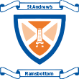
Year 5/6 Spring 2 Topic Plan
Super Sleuth

