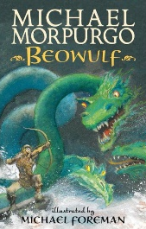
English – Our English writing will be based on the book ‘Beowulf’ by Michael Morpurgo. We will be using this text to understand what legends are, and then use the book as a model to write our own. We will also explore kennings using figurative language. We will also write some persuasive texts based on our geography work.
Grammar & Punctuation – We will be revising word classes during the first week of the half term. Then we will focus on phrases and clauses, expanded noun phrases and active and passive verbs.
Guided Reading – We will be using the text to explore different themes such as heroism, friend, or foe. Children will be encouraged to predict what might happen from information stated and implied.

Maths – We will be exploring 1. Place Value (numbers to 1 million and 10 million, ordering numbers, negative numbers, counting to the power of 10, rounding numbers). 2. Mental / written addition and subtraction (choosing appropriate strategy, solving multi-step problems, estimation, adding / subtracting decimals). 3. Geometry / measures and shape (angles, perimeter, measurements and calculating measurements, draw shapes and nets)

Science – We will be looking at ‘Properties of materials’ in Science this half term. Children will learn to group and compare everyday materials and their uses, explore materials extracted from natural resources, explaining their uses and investigate the properties of materials.
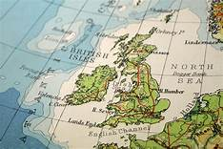
- Geography – In Geography, we will research what, exactly, is meant by the UK and GB. (“The United Kingdom of Great Britain and Northern Ireland” is more commonly known as the United Kingdom. Great Britain comprises only England, Scotland and Wales - not Northern Ireland). We will also research (some of) the counties of each of the four countries and look at some of the unique physical or human features in the UK.
- History – In history, we will be doing an in-depth study of the Anglo-Saxon period, using appropriate vocabulary when describing the passing of time and historical concepts.

P.E – Our PE unit this half term is going to be on Health and Fitness. This will link well with our Science topic and will give us the opportunity for some cross-curricular learning. We will be creating some of our own fitness circuits and understanding how exercise impacts the body.
R.E. – The focus of our RE lessons this half term will be about the Bible.
ICT – We are going to be looking at coding with Technola in our ICT lessons this half term. Students design and build their own multi-stage mazes for their peers to solve as they
consider the question, ‘how can code help us to tackle problems with unpredictable
elements?’
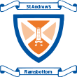
Year 5/6 Autumn 1 Topic Plan
A Kingdom United

